Project-Aii: Zero Trust & AI Integration for
Identity Access Management & Communications and Network Security

Introduction
The two Certified Information Systems Security Professional (CISSP) domains that we will be focusing on in this project are Identity & Access Management, and Communications & Network Security. Identity & Access Management (IAM) focuses on system access, authorization, identification, authentication, and verification of individuals attempting to access a system (Deane & Kraus, 2021, p.377). Communication & Network Security is primarily comprised of the two principles of layering and domain separation although there is a massive expanse of network types, and setups (Deane & Kraus, 2021, p.284). The purpose of this project is to provide a use-case for Artificial Intelligence (AI) in these fields, and in our professional interest, in conjunction with a common Customer Relationship Management (CRM) database by Oracle called PeopleSoft, Cisco Duo Multi-Factor Authentication (MFA), and a zero trust architecture (ZTA) to enable the University of North Texas (UNT) to deploy ZTA with AI enhancements, reducing the burden of manual user authentication, role/permission management, and enhancing communication and network security. We will also look at other opportunities that AI could provide to further strengthen network access and user authentication, while reducing the manual interventions by students, faculty, and staff.
First, we must understand what makes up IAM, which Ajish (2024, p. 7-11) indicates contains four fundamental pillars: Authentication, Authorization, Administration, & Auditing/Governance/Compliance; Authentication is the focus of verifying identities of users allowing only valid user system access, Authorization regards the extent to which a user can access a system via roles and permissions, Administration is the management of user accounts, roles, and permissions, and Auditing is the monitoring and recording of access events to detect security threats, enforce compliance, and maintain a record of user activities.
Next, Deane & Kraus (2021, p. 284) define Communication & Network Security (CNS) as two primary principles: Layering and Domain Separation; Layering is the designing of a system in increasingly abstract terms with each layer offering an aspect of security assurance, whereas domain separation is the separation of network traffic at collision domains, broadcast domains, and segments in order to avoid network congestion, and adversaries developing understandings of network topology. Beyond these two principles, CNS is concerned with data encryption/decryption, and malicious processes attempting to enter the network, or extract information from it.
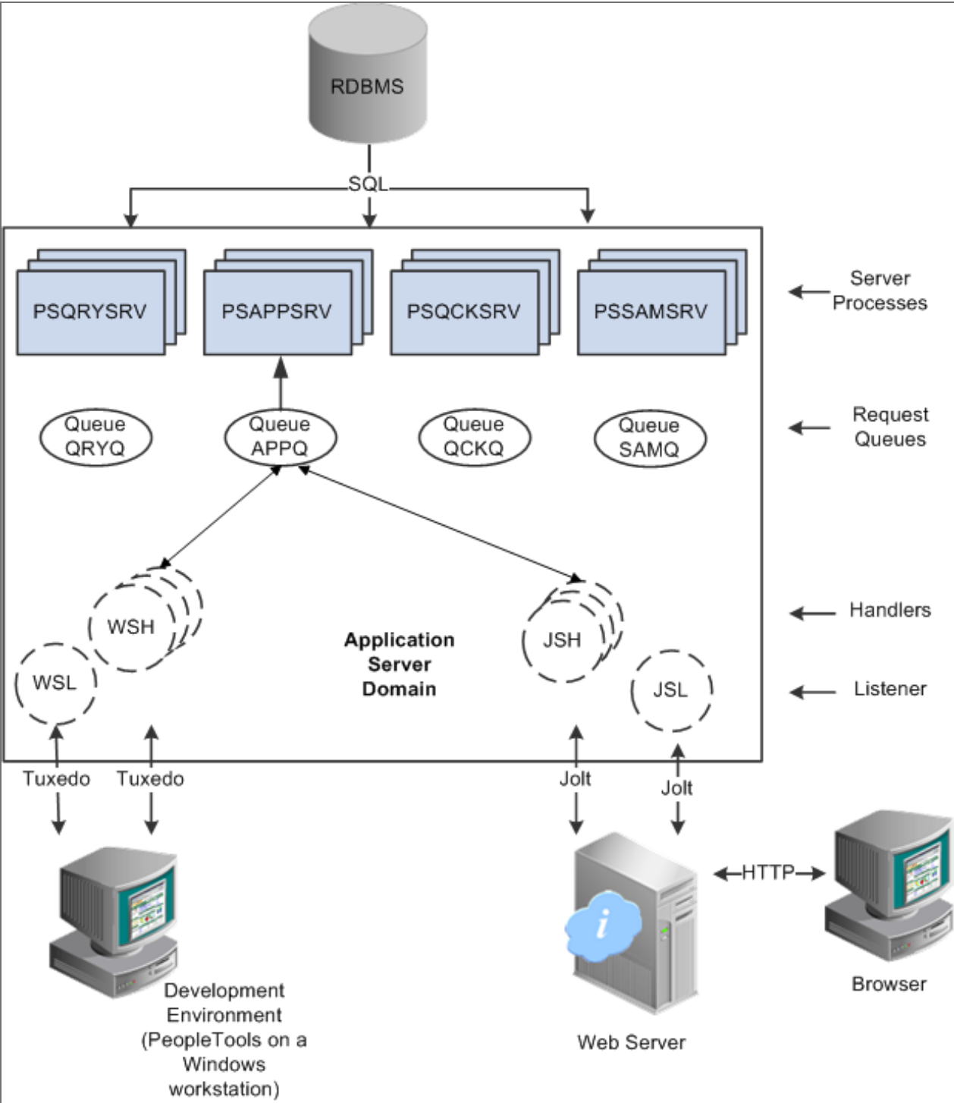
Figure 1 - PeopleSoft Internet Architecture (PeopleBooks, 2024, p. 3)
Finally, we must understand how these domains of CISSP interact with Zero-Trust Architecture (ZTA), a model which “fundamentally shifts the security paradigm by assuming that no network boundary is inherently secure”, and which incorporates the principles of continuous verification, compartmentalization to limit the “blast radius” of compromises, and automates context collection and responses using behavioral data to create a holistic overview for security incident response Ajish (2024, p. 4). This type of model has increased in significance within the last few years as the post-covid workforce began to normalize working-from-home, using personal devices, and connecting from outside networks to internal networks. Ajish (2024, p.4) further adds that there are 7 pillars of a Zero Trust Architecture: Identity, Device, Network, Application, Data, Visibility, and Automation all of which are points to compartmentalize and secure which further ensure IAM & CNS. When looking at AI solutions and what they provide, it is important to keep in mind how they impact a ZTA and the core principles: always verify, use least privilege access, and assume breach; the most effective architectures have well-classified data to provide additional insights for trust-based decisions, and the use of monitoring to detect and stop anomalous behaviors (Deane & Kraus, 2021, p.163-164).
As we continue, we will be focusing on these concepts as they apply to the University of North Texas, and the currently existing infrastructure of multiple PeopleSoft databases, UNT network access, and DUO MFA. The scope of this project is to understand how AI can provide increasing security benefits with minimal manual intervention from users to this environment by improving automation for roles/permission management, network access, and Adaptive MFA (AMFA) which provide increased security with reduced manual intervention.

Project Concept Map
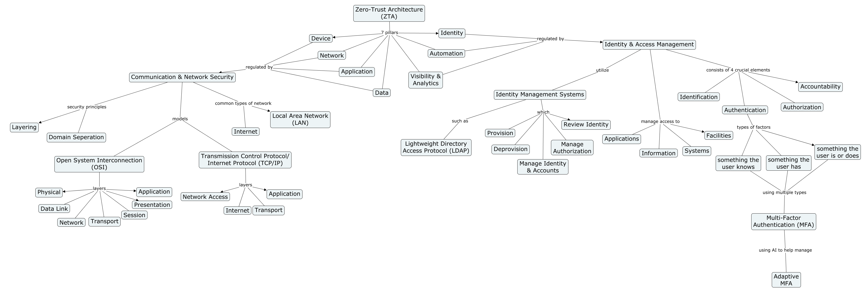
Figure 2 - Concept Map of the two CISSP domains and Zero-Trust Architecture.

Processes of the AI Application in ZTA & A UNT Case Study
The first and primary milestone of AI in Zero-Trust Architectures (ZTA) as it pertains to authentication is how it could benefit the University of North Texas in strengthening MFA into Adaptive Multi-Factor Authentication (AMFA), ensuring the ZTA pillars of identity, device, and network; aiming to ensure only authorized users access the resource, securing endpoints and trustworthiness, and monitoring network traffic (Ajish, 2023, p.4). UNT had recently introduced the MFA platform DUO to students, faculty, and staff to create a ZTA for individuals logging into the primary customer-relationship management (CRM) database PeopleSoft (PS), as well as the Cisco VPN to remote into the network and workstations. The PeopleSoft database is comprised of multiple separate sources of record like Student Records, Faculty/Staff Human Resources (HR), and multiple Quality Assurance and Development environments. To provide customer ease of access, all previously mentioned database environments, use Oracle’s Single Sign-On (SSO), which allows individuals to have one set of credentials to log into multiple separate databases (PeopleBooks, 2024, p.2).
The issue with SSO, particularly with Oracle’s deployment is that it uses web-based cookies to authorize and continually authorize after a user has logged in (PeopleBooks, 2024, p.2), so there are cases where systems have been attacked using a TokenChpoken attack, which uses an authorized token to then create and generate more tokens to try and access parts of the database which are restricted to the original token (Tyurin, 2018, slide 52). Thus, the introduction of MFA created an extra verification layer to individuals signing-in, ensuring identity, device, and network trust, and preventing credentials being stolen or fabricated. This fix however meant that students, faculty, and staff are now required to use the DUO MFA application at sign-in, even verifying multiple times in a row to connect to the Cisco VPN, Remote Desktop Connection, and a database environment. This can end up asking an individual, especially people who are students and staff, to verify their identity over 12 times in an 8-hour workday.
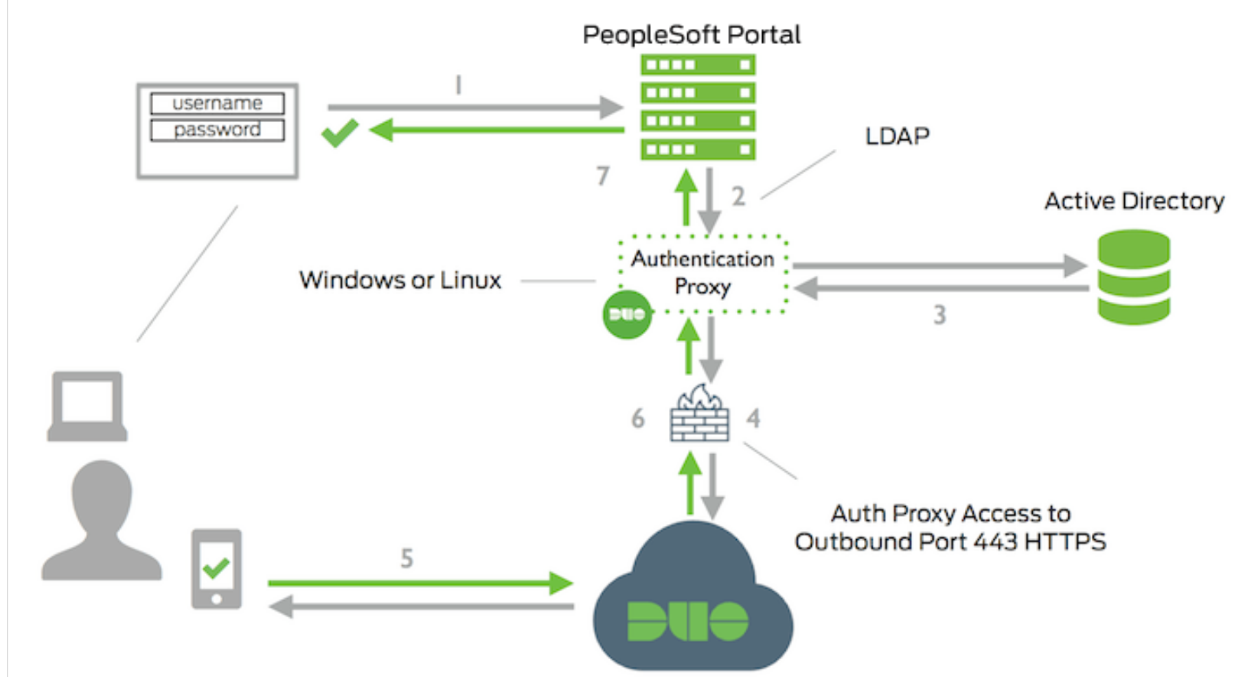
Figure 3- DUO & PeopleSoft Integration Network Diagram (Cisco Duo, 2024)
Adaptive MFA looks to solve this issue with contextual verification, risked-based authentication, and biometric & token authentication (Ajish, 2024, p.14). By collecting information on user behaviors and analyzing them, known as User-Behavior Analytics (UBA), companies like UNT can verify the individual’s identity by matching behaviors to previous patterns.
This is also combined with the standard PeopleBooks security features (2024, p. 2) which create user profiles, and assign permissions through custom roles, which are stored in a Lightweight Directory Access Protocol (LDAP); LDAPs act as a centralized directory which stores user profiles and user authentication, allowing for constant synchronization and reducing redundancy.
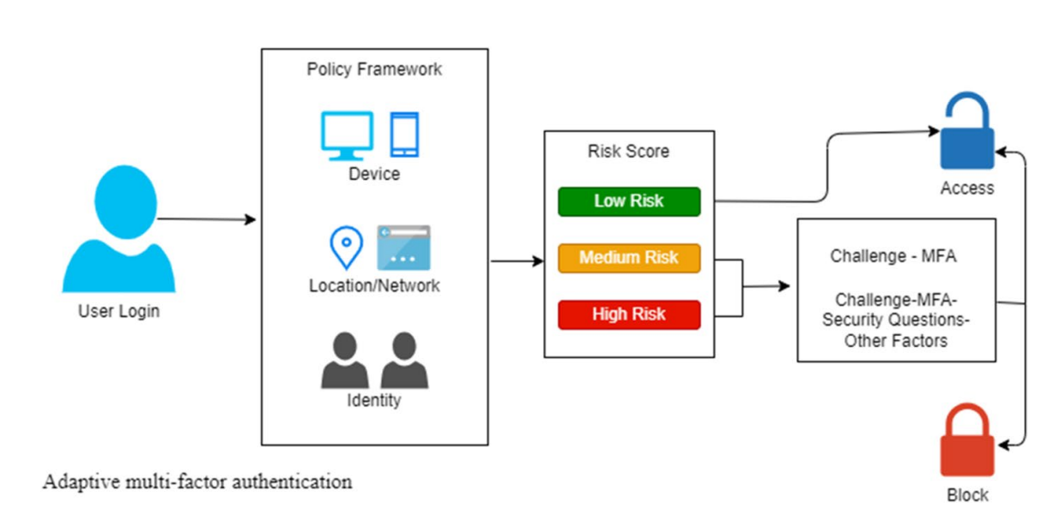
Figure 4 - Adaptive Multi-Factor Authentication (Ajish, 2024, p.13)
For the use-case of AMFA, a user would be given a risk score based on the permissions and access levels in the database, IP location, device type, and UBA where students may be considered low-risk, and developers might be considered high-risk. A low-risk user may only be prompted for MFA if they are logging in for the first time of the day, or are logging in from an IP address not associated with the account. Whereas a developer may receive a prompt to verify their authentication initially when logging in even if their IP address is the same, and possibly required to complete more advanced authentication requirements if logging in from out-of-state, from a new device, or if they have access to Personally Identifiable Information (PII). Once everyone has been verified, AI can be used further for Continuous User Authentication using UBA, behavioral biometrics and anomaly detection which would prompt a user to re-verify if an anomaly is detected (Ajish, 2024, p.7-8).
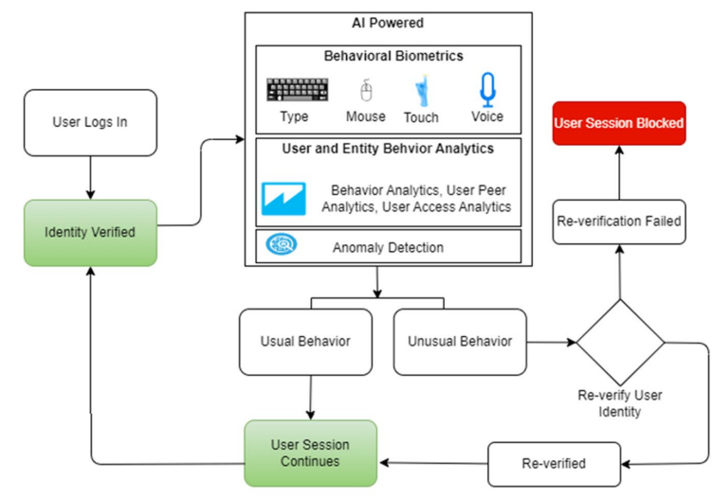
Figure 5 - Continous User Authentication (Ajish, 2024, p.7-8)
Ajish (2024, p. 9-10) also add that beyond AMFA, AI can be used in conjunction with these LDAPS for Administration purposes of the ZTA, like Role-Based Access Controls which are fertile grounds for automation intaking UBA, user activities, and AI to perform other ZTA roles like Authorization management via Role Mining & optimization, dynamic access control, and continuous role reviews which assist the ZTA pillars automation and governance. This would reduce the need for a system administrator having to manually review and assign roles to an individual, by leveraging user information like job title, division, department, manager, and UBA to automate access requests, user profile management, and assigning roles and permissions. This also means that AI could be used for administration purposes like de-provisioning user access, and automating access requests, which can often be overlooked or be delayed based on HR processes and timing.
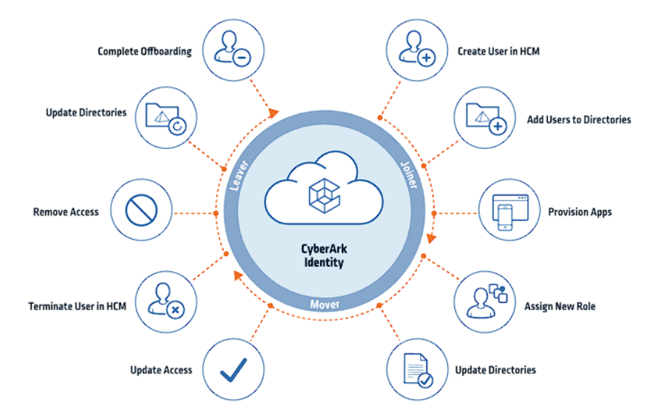
Figure 6 - Access Lifecycle Management with AI (Shaik et al., 2023, p.16)
Lastly, AI can provide monitoring, logging, tracing and auditing, to further increase network security using advanced statistical concepts like supervised Machine Learning (ML) to identify malware, spam, and differentiate human-generated DNS records from ransomware (Veiga, 2018, p.6). Veiga also states that companies like Darktrace claim that by using AI they can detect and react to network attacks and ransomware, citing a case where Darktrace was able to identify a malicious software downloaded from an employee e-mail in nine seconds, and was able to autonomously stop the anomalous writing activities twenty-four seconds later (2018, p.11). These logs and actions then can be further reviewed by the security team at their earliest availability to ensure the process that was stopped was truly malicious, ensuring that in the event of a false positive, teams can include that data to re-train the AI model.
Benefits, Opportunities, Cost, and Risk
The benefits of AMFA are primarily for the end-user’s convenience, by reducing the number of times a user is required to manually authenticate themselves, but it also benefits the company to begin creating logs of user activity to create baseline behaviors which can be used for later anomaly detection. The whole idea of having Adaptive MFA requirements that change per user would seem counter-intuitive to the zero-trust architecture, however, Ajish (2024, p.14) argues that AMFA provides a cloud ready, scalable solution which strengthens the architecture by including contextual verification like device and location, biometric token authentication, and risk-based authentication which varies by user risk.
Another benefit of AI would be the inclusion of Continuous User Authentication, which would monitor the activities of users for unusual behavior or anomaly detection (Ajish, 2024, p. 7-8). This means that if a bad actor can bypass the initial AMFA, that if at any point someone began downloading massive amounts of data, or trying to access restricted pages, that their behavior would be flagged for re-verification, which may include more stringent requirements, therefore compartmentalizing and reducing the blast-radius of would-be attackers.
Beyond using UBA for Continuous User Authentication, Shaik et al. (2023, p. 11) indicates that these behaviors would also directly contribute to enhanced threat detection, real-time threat response, reduced false positives, and improved security posture.
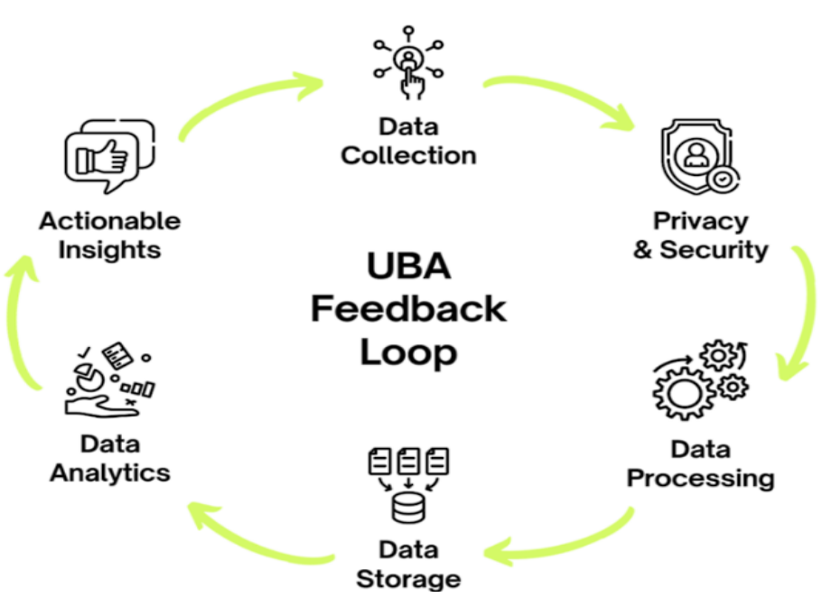
Figure 7 - The UBA Feedback Loop (Shaik et al., 2023, p.9)
These benefits do come at a high cost of time and money for implementation though, as data must be gathered to create baselines for user behaviors, or to be able to consolidate roles and permissions while avoiding overfitting or false positives which ensures the AI is not handing out access to pages with confidential information based solely on job title (Shaik et al., 2023, p.23). Shaik et al (2023, p.11) also raises there is a concern about data privacy and evolving threats, which would require monitoring and maintenance from staff, and a robust data governance practice to ensure end user privacy protections.
This means that the set-up time required would be extensive in training the AI model which would regulate role creation and permission assignments, as well as de-provisioning users. The positive of this is that instead of replacing currently existing roles within a company that deal with access and security, these roles would begin to work with the AI models to provide oversight, further training, and manual interventions.
Impacts or Practical Implications
While these implementations might seem out of reach for a company unless it were Google, the truth is that implementations like these would need to be strategized and researched to make sure an implementation has the time and staff to create, deploy, and monitor a solution which provides results. For instance, it might be difficult to manage the deployment of a UNT System-wide AMFA or automated role provisioning, however research to find the largest communities, individual type, or need could mean a solution is deployed which positively impacts a large population at the university. This means iterating and beginning with an AI implementation that manages access for basic staff roles which do not have access to confidential information, to ensure that a complete Access Management Lifecycle can be created initially before further deployment.
Another early deployment could be implementing AMFA for low-risk populations like students, individuals who do not use the database frequently, and cannot access other student/staff information, which can be a test study for implementing UBA and continuous authentication, before proceeding to a higher risk group.
Lastly, while using UBA to monitor user behaviors may have privacy concerns which would affect the rate of implementing a solution, however these types of models could be used to flag anomalous activity, automatically stop or alert security staff, and train further without being the sole means of preventing malicious activity.
Future Research
The future research for AI implementation with IAM within a zero trust model according to Shaik et al., are explainable AI, federated learning, and continual learning (2023, p. 26-27); Explainable AI would be furthering the transparency and trust in allowing AI systems to moderate IAM sectors, federated learning allows AI to train on decentralized data without user privacy being compromised, and continual learning is the development of AI to train on continuously collected UBA and new threats in order to maintain reactiveness and responsiveness to new behaviors and threats.
Another area for further research in regards to Communication & Network Security would be egress filtering, the analysis of outbound traffic as it leaves the network (Malhotra, 2007, p.8). While filtering unencrypted data does not require as much involvement, the process of looking through encrypted data can be much more difficult, however the analysis of entropy and randomness of the data streams could prove to be a method in which companies can still analyze and filter data leaving the network (Malhotra, 2007, pg.45).
Project Lessons Learned
Due to an ever-evolving demand for customized and high functioning products which must defend against day 0 attacks, and constant malicious bombardment, the technology sector, especially for cybersecurity, has had to develop exponentially and constantly to defend customers (Ajish, 2024, p.2). The easiest defense is to lock down a system to local networks, always require multi-factor authentication, and never trust anything, however these systems would have difficulty scaling, or meeting the rapidly expanding consumer requirements that solutions such as Software-as-a-Service (SaaS) and cloud operation have been able to create (Oracle, 2024). The issue is though that these SaaS or cloud-based databases are now extremely vulnerable to constantly evolving attack types, as they transmit confidential data from remote servers over the internet to many different users, devices, and customers (Ajish, 2024, p.2).
The solution to reduce the amount of tedious manual intervention, which could be a source of human-error, is to have AI incorporated as a partner in assisting with Communication & Network Security, and Identity & Access Management. While AI solutions such as User Behavior Analytics, Adaptive Multi-Factor Authentication, Role Mining and Automation, Automated provisioning/de-provisioning, Continuous User Authentication, Anomaly Detection, and Automated Audit Trail Generation all add to a zero-trust architecture, they are all massive projects to implement. This does not mean it is not possible however, as they can be seen by companies like Oracle and UNT as tools which can provide increased security and proactivity, and as tools which do not replace jobs, but cooperate with pre-existing roles to reduce the tediousness of constant identity verification, or role management, which could lead to apathy from end-users, administration, and staff managing the systems.

References
Ajish, D. The significance of artificial intelligence in zero trust technologies: a comprehensive review. Journal of Electrical Systems and Inf Technol 11, 30 (2024). https://doi.org/10.1186/s43067-024-00155-z
Deane, A.J. & Kraus, A. (2021). Domain 3, 4 & 5 (p.163-418) Official (ISC)² Guide to the CISSP CBK, Sixth Edition, Wiley.
Duo Two-Factor Authentication for PeopleSoft. Cisco Duo. (2024). https://duo.com/docs/peoplesoft
Learn about SAAS. Oracle. (2024). https://www.oracle.com/applications/what-is-saas/
Mahammad Shaik, Leeladhar Gudala, and Ashok Kumar Reddy Sadhu, “Leveraging Artificial Intelligence for Enhanced Identity and Access Management within Zero Trust Security Architectures: A Focus on User Behavior Analytics and Adaptive Authentication”, Australian Journal of Machine Learning Research &amp; Applications, vol. 3, no. 2, pp. 1–31, Jul. 2023.
Malhotra, P. (2007). Detection of encrypted streams for egress monitoring (Order No. 1447482). Available from ProQuest Dissertations & Theses Global. (304858636). https://libproxy.library.unt.edu/login?url=https://www.proquest.com/dissertations-theses/detection-encrypted-streams-egress-monitoring/docview/304858636/se-2
Security Administration. PeopleBooks 8.51. (2024). https://docs.oracle.com/cd/E24150_01/pt851h2/eng/psbooks/tsec/book.htm. Page 2.
System and Server Administration. PeopleBooks 8.51. (2024). https://docs.oracle.com/cd/E24150_01/pt851h2/eng/psbooks/tsvt/chapter.htm?File=tsvt%2Fhtm%2Ftsvt03.htm. Page 3-10
Tyurin, A. Oracle Peoplesoft Applications Are Under Attacks! (2018) https://web.archive.org/web/20181118151138/https://erpscan.com/wp-content/uploads/presentations/2015-Hack-In-Paris-Oracle-PeopleSoft-applications-are-under-attacks.pdf
Veiga, Alberto P. Applications of Artificial Intelligence (AI) to Network Security. University of Maryland University College. March 2018. P 1-11.
https://doi.org/10.48550/arXiv.1803.09992

